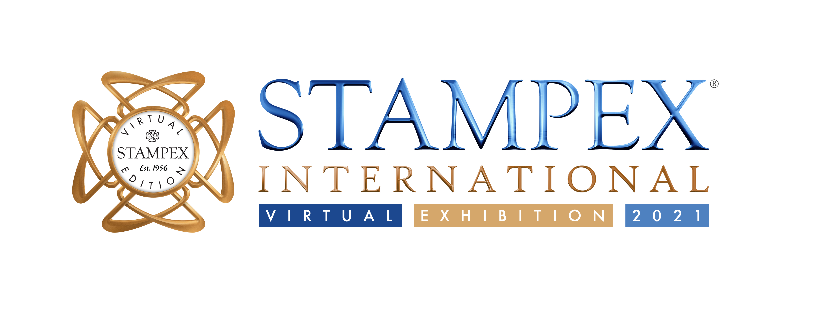

PTS Announce New Chairman and Managing Director

November 2021: The Philatelic Traders’ Society is delighted to announce its new Chairman, Simon Carson. Simon Carson has been a member of the PTS Council since 2015 and has most recently held the position of Vice Chairman.

After 3 years as PTS Chairman, Suzanne Rae will take on a new role as the PTS’s Managing Director as of November 2021.

Shifting the society’s organisational structure in this way recognises the need for this new senior professional position within the PTS team. Suzanne will report directly into the PTS Chairman and Council. In her time as Chairman, and working extensively with the PTS Council, Isobel and Helen, Suzanne has steered the society through a global pandemic, brought in new offers and initiatives such as Virtual Stampex, new physical Stampex concepts, the eBay Authorised Seller Partnership, the globally recognised PTS Awards, the PTS Collector Handbook, our ‘Look for the Shield’ and Proud Member campaigns and online Smiler Shop. Suzanne has worked with the team to streamline back office processes, grow our membership, improve member and external communication, promote our members in new and creative ways, integrate new technologies into how we do things, and positioned the PTS as the International Society for Philatelic Professionals. There is still work to do to ensure the society can thrive and the PTS Council is delighted that Suzanne will continue to drive forward the future agenda in this new role. The Council is also thrilled that Vice Chairman, Simon Carson will be stepping into the Chairman position to bring a fresh perspective and new energy to the society.

Simon says: “I am so proud to be taking over the baton as PTS Chairman. I truly believe that we have a world class society and Stampex brand, with a host of remarkable and diverse members who all add something to who we are and what we do. I look forward to meeting many of our members and partners face to face and remotely over the coming months and welcome any ideas and feedback on how we can make our society even stronger.”

Suzanne says: “It has been an incredible honour to have acted as PTS Chairman from 2018-2021. The society has taken up a lot of my head space over the past few years, but it has also taken up a lot of my heart space. I am excited about what and how I can deliver even more in my new role, hand in hand with Simon. I remain committed to delivering the best possible benefits for our members and to ensuring that the society remains bold, innovative, professional and community led in how it promotes its members, supports the trade and boosts the hobby.”

For more information, photography or comments please do contact isobel@thepts.net

