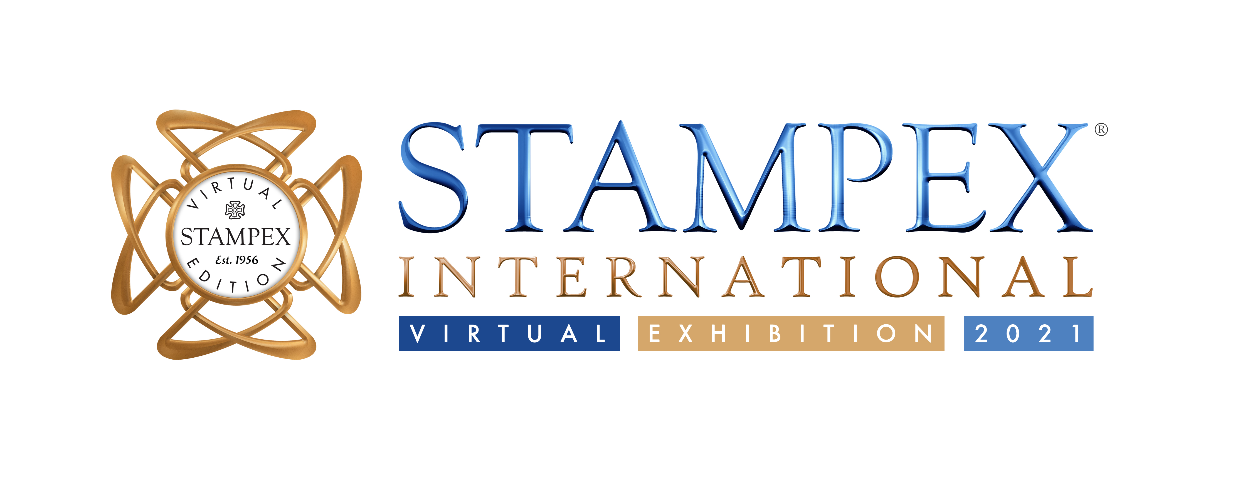

Virtual Stampex In Numbers

Virtual Stampex was an exciting addition to the philatelic calendar. The live show lasted for 3 days with the On Demand period running until end of April.

Here is a snap shot of the show in numbers

- Live for 72 hours and On Demand for 28 days.
- The show was visited by people from 118 different countries.
- Top 10 countries where visitors were from included UK, USA, Canada, Australia, India, France, Germany, Netherlands, Italy, Belgium.
- 15 Live Talks with a total of 2,451 live views and hundreds of more visitors now watching these On Demand.
- 11 Meet the Team sessions in Collectors Lounge and 11 Collector Support Sessions.
- 42,998 Booth Visits and 32,032 Unique Booth Visits.
- 13,429 Booth tabs clicked and Booth file downloads.
- 37,125 clicks around the Lobby during the Live Event.
- 1,013 SwagBag / Virtual Briefcase downloads during the Live Event.
- 324 Live Views of the The Stanley Gibbons Stamp Catalogue; past, present and future by Hugh Jefferies (MBE)
- In the first 24 hours of the show, unique visitor numbers were up 15% on October 2020, and after 48 hours, unique visitor numbers were up 18% on October 2020

Chairman of the PTS, Suzanne Rae comments

‘The Philatelic Traders' Society are really proud of what we have established. Virtual Stampex gave us another opportunity to open up our values of philatelic professionalism, passion, community and innovation to the world. From the ever-popular Stampex Talks in the Spink Auditorium, to the new Collectors Lounge, to a wide range of exhibiting attractions, to phenomenal materials, deals and collector support from our PTS Members booths, Virtual Stampex 2021 was without a doubt, a show to remember. We are now incredibly excited about how we can continue to develop Stampex (virtually and physically) as a leading philatelic experience."

Sign up to the show at stampex.vfairs.com to attend the On Demand show until 28th April.

For more information email Isobel Klempka isobel@thepts.net

About Virtual Stampex
Virtual Stampex is organized and managed by The Philatelic Traders Society. Founded in 1929 The PTS is one of the longest standing trade bodies in the industry. The PTS is the international society for philatelic professionals; ensuring businesses trade with integrity and follow the code of ethics. The PTS also runs the biannual Stampex International hosted at the Business Design Center in Islington, London. Information for both shows can be found on the website www.stampexinternational.co.uk

