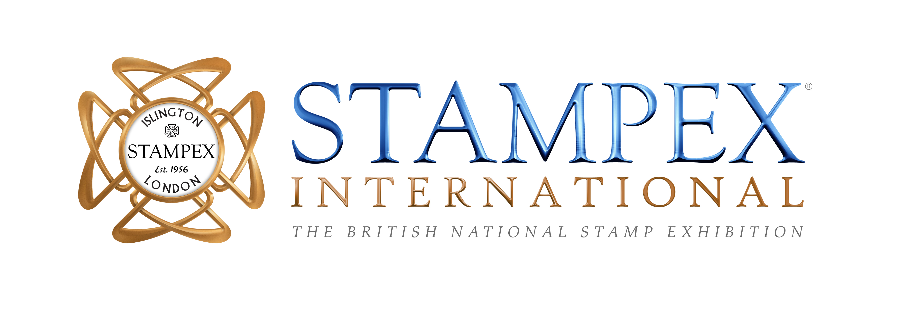

TICKETS SALES LAUNCHED FOR STAMPEX 2022

May 2022, London: The Philatelic Traders’ Society are delighted to announce that tickets for Stampex, 28th September - 1st October 2022, have launched with an exciting early bird offer. Proudly sponsored by iconic auction house Spink, the now once a year, international show brings the philatelic community together, welcoming businesses, societies, exhibitors, influencers and hobbyists from all over the world who all love stamps. This is your chance to join us to enjoy the hobby, learn something new, connect with friends and add items to your collection. The new look and feel show featuring the Stampex Talks Auditorium, a Collectors Lounge, Digital Zone and new Youth Zone all initially showcased at Stampex 2021, will be enhanced further presenting more collector opportunities, more exciting talks and more initiatives to help you make the most of your day (or days!) out.

Suzanne Rae MD comments
‘We will be announcing new changes and exciting attractions over the coming months so the best way to keep up to speed is to sign up to our newsletter at www.stampexinternational.com/signup or follow us on social media @theptsandstampex. We are constantly working on ideas to help keep the hobby fun and engaging for collectors and for those just starting out on their own philatelic journey.’

GENERAL INFO
Please find all details about the event and register your attendance at: www.stampexinternational.com/tickets

Early Bird price: £10.00 ticket opening day (includes show guide)
Free Entry Thursday – Saturday and families welcome

VENUE
THE BUSINESS DESIGN CENTRE, 52 UPPER STREET, ISLINGTON, LONDON N1 OQH
Nearest Tube Station-Angel Islington (Northern Line)

DATES/TIMES:
Wednesday 28th September: 10:30 – 17:30
Thursday 29th September: 10:30 – 17:30
Friday 30th September: 10:30 – 17:30
Saturday 1st October: 10:30 – 16:00

FOR MORE INFO OR TO JOIN THE SOCIETY PLEASE VISIT
www.thepts.net or www.stampexinternational.com

For further information, contact Isobel Klempka isobel@thepts.net

About the Philatelic Traders’ Society
Formed in 1929 by a group of established stamp dealers, The Philatelic Traders’ Society was created to act for and on behalf of its members for the good of philately. With a Code of Ethics and a service for dispute resolution, The Philatelic Traders’ Society is regarded as a reputable organisation within the industry, upholding the values of honesty and integrity. The PTS also organises Stampex – the UK’s leading philatelic exhibition. www.thepts.net

